Gross anatomy of kidney

Shape
Located in dorsal upper lumbar region of abdomen
Hilum corresponds to body of L1 vertebra
Right kidney is slightly lower than the left as large liver is present in right hypochondriac area

Poles, borders, surfaces
Poles - superior and inferior
Borders - medial and lateral
Surfaces - anterior and posterior

Peritoneal relationship
Kidneys are retroperitoneal
Only anterior surface is partially covered with peritoneum
Posterior surface is related directly to posterior abdominal wall

Movement with respiration
Clinically movement of kidney with normal tidal respiration is not demonstrable
On deep inspiration kidney moves downwards
However - slight movement of kidney with respiration is important during defining targets for radiotherapy

Physical examination of kidney
With patient in supine position, kidneys are palpated bi-manually in right and left lumbar regions
Kidney is lifted by one hand in costovertebral angle.
On deep inspiration kindey moves downwards

Surface marking

Morris parallelogram
Identify spines of T11, T12, L1, L2 and L3. Line joining them will be the midline.
At spine of T11 - draw a horizontal line
At spine of L3 - draw a horizontal line
Draw a vertical line at 2.5 cm lateral to midline
Draw another vertical line at 9 cm lateral to midline
This results in two parallelogram on either side
Draw left kidney with hilum at L1 - little higher, so that it touches the upper horizontal line
Draw right kidney with hilum at L1 - little lower, so that it touches the lower horizontal line
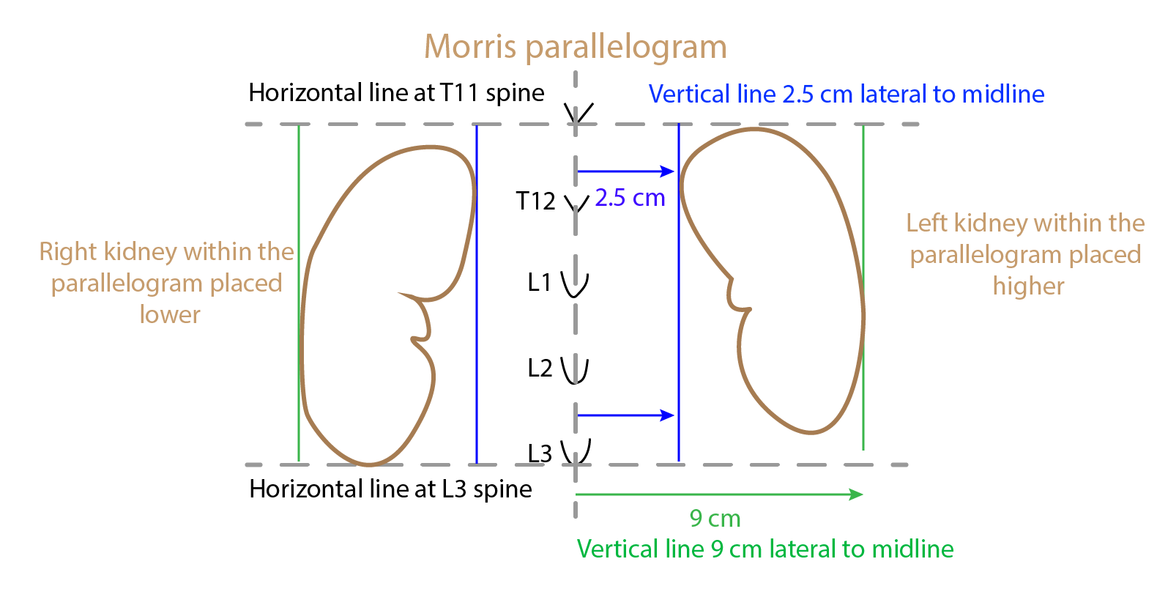

Morris parallelogram - surface marking of kidney

Structures at kilum of kidney
From anterior to posterior
- Renal vein
- Renal artery (usually divides before entering the kidney)
- Renal pelvis
Lymphatics and sympathetic nerve are also present at hilum
Renal hilum is located at body of L1.

Renal vascular segments
Renal artery divides into 5 segmental arteries
- Apical
- Upper anterior
- Middle anterior
- Lower
- Posterior
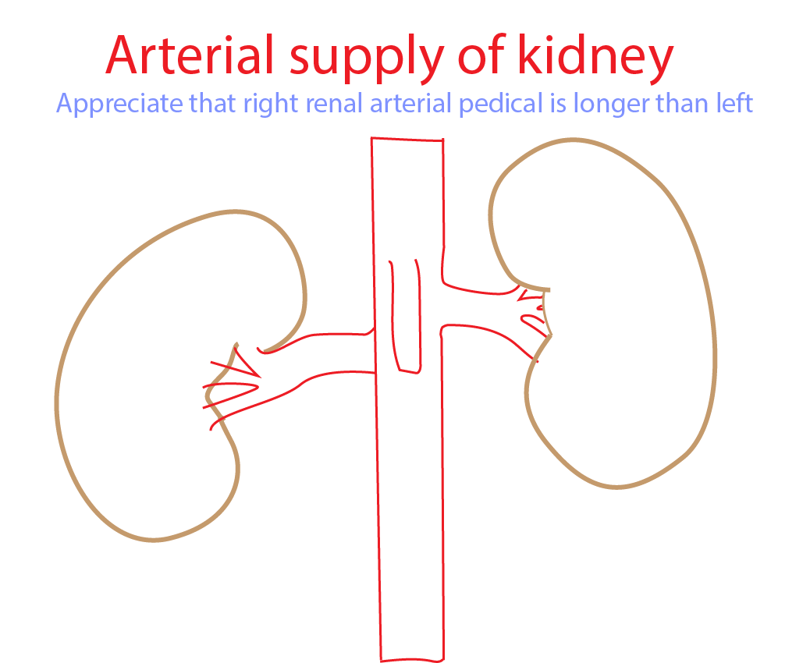
Renal arteries
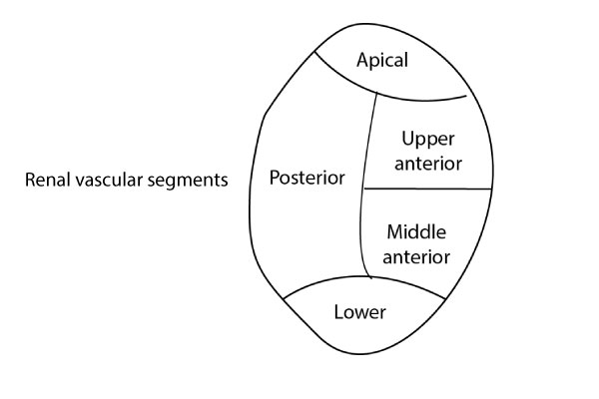

Variations are common
- Unilateral multiple renal arteries are common in as many as one fourth of general population
- Multiple renal arteries supply one segment
- Accessory renal arteries supply only part of a segment
- Accessory renal arteries may be superficial or deep to gonadal vessels.
- Accessory renal arteries can compress ureter and may result in hydronephrosis
- Accessory renal arteries are common on left side and supply lower pole
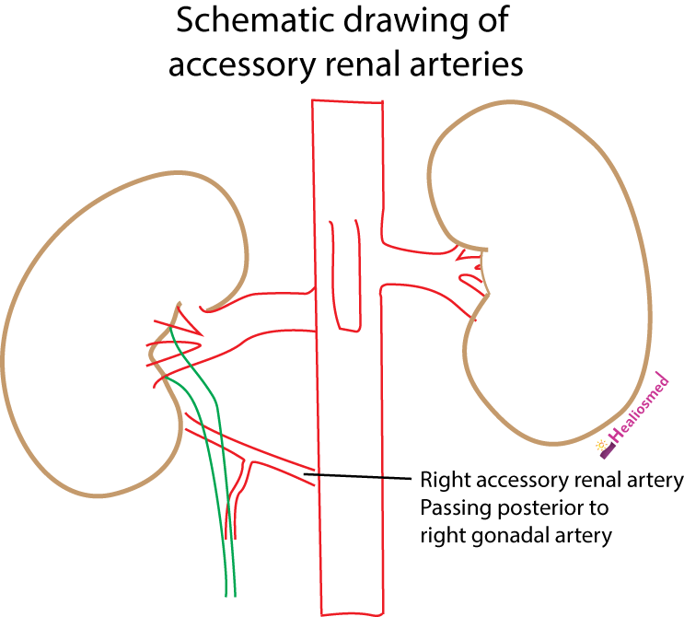
Accessory renal arteries on the right side

Importance of renal vascular segments
Clinical significance in partial resection and transplantation of the human kidney

Renal angle
Angle between
- Lower border of the 12th rib and
- Lateral (outer) border of erector spinae muscles

Importance of renal angle
Renal angle tenderness indicates renal pathology
- Renal stones
- Renal abscess
- Pyelonephritis

Renal transplantation - anatomical considerations

Donor
- In live related donors - left kidney is used as the length of renal vein is longer on the left side. Additional renal veins are lesser on left side

Recepient
- Donated kidney is transplanted in iliac fossa
- Renal artery is anastomosed with external ilac artery
- Renal vein is anastomosed with external iliac vein
- Donor ureter is anastomosed with the recipient bladder

